Parent Information
- 30-day grace period for Free/Reduced lunch ends 9/24/19. You will need to refill out the online forms.
- Lunch payment accepted 8-9:30 am (not during lunch line)
- Account information for student’s lunch/balance will need to be checked AFTER all students have come through the line.
- Snacks will be SOLD AFTER ALL lunch buyers have come through the line.
- If there is a block on your student account, THEY CAN NOT BUY EXTRA.
- No verbal authorization for blocking accounts. You will need to contact the LISD Child Nutrition Office (469) 713-5200.
- Food Allergies require a doctor’s note and must be given to Elanine Minden (469) 948-2012.
- We cannot give change back.
- No parking in the fire lanes/red zones.
- Park in parking spot ONLY. The back is for delivery and waste management. Please do not remove red cones and park.

Teachers:
- 2nd-5th can help us keep the tables clean and learn responsibility by wiping down the tables after lunch.
- A teacher needs to be standing in the door to keep the students in order and help cut down on the noise and behavior.
- No ADULT lunch charging. No exceptions! LISD policy!
- We cannot make change. We have very limited funds.
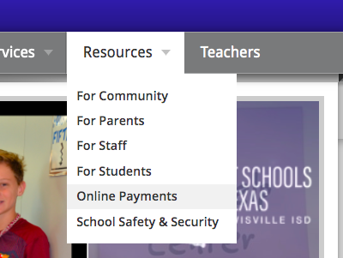
- Please share the “Online Payments” access online with parents at Parent Orientation. There will be a table with computers available to parents tonight by the library.
Go to Hicks ES Website
Click on “Resources” tab
Choose “Online Payments”

