Forces of Motion Assessment
- Students conducted an investigation in which they let the same car roll down the same ramp in three different locations in their school with three different floor types, as shown below. Which of the following questions was this investigation most likely designed to answer?
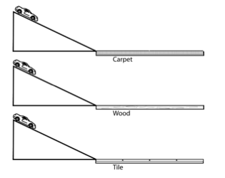
A | How does the mass of a toy car affect its speed?
B | How does friction affect the distance a toy car rolls?
C | What mechanical advantage does an inclined plane give?
D | Why does gravity make a toy car roll down a ramp?
- Students are going to test how the mass of an object affects its movement. They will use an electric fan to blow air on a set of playground balls and measure how far they travel before stopping. What is an important component of the design of this investigation?
A | The fan will need to have low, medium, and high settings.
B | Students must measure the distances in millimeters.
C | The investigation must be done outside on the playground.
D | Students need balls of different masses, but of the same size.
- Students are investigating the forces that act on a wagon as it rolls down a hill. Which of the following would be the best way for students to determine how the mass of the wagon affects the speed it rolls down the hill?
A | Attaching rubber bands to the wheels of the wagon
B | Starting the wagon from different heights on the hill
C | Adding one, two, or three bricks to the wagon
D | Pushing the wagon with different forces at the start
- Students dropped marbles into graduated cylinders filled with the same amount of three different liquids. The time it took the marble to reach the bottom was recorded in the table below. The procedure was repeated three times for each liquid. The students believe that the measurement of 2.2 seconds for Trial 3 of Liquid 3 is incorrect. Which of the following is the most likely explanation of what caused the error?
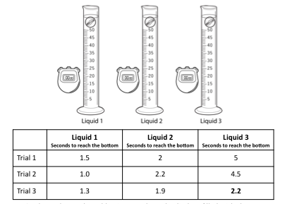
A | Liquids 1 and 2 became warmer after several trials
B | The stopwatch was started too late for the one trial
C | All the marbles became coated with the different liquids
D | The graduated cylinder was too narrow for the marble
- Students are going to conduct an investigation in which they will need to measure the speed of an object. Which two tools will they need to get the appropriate measurements to determine speed?
A | Balance and meter stick
B | Meter stick and ruler
C | Timer and safety goggles
D | Meter stick and timer
- A student uses a spring scale to pull a 50-gram block horizontally across a wood desk. Then the student pulls the block the same distance across surfaces of carpet, sandpaper, and glass.
Which question is this investigation most likely designed to answer?
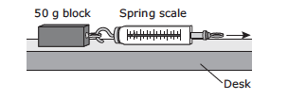
A | How do blocks of different sizes react to force?
B | How do different surfaces affect the amount of force needed to move a block?
C | How do blocks affect spring scales?
D | How does the mass of a block change when it is pulled across a desk?
- Some students attach a balloon to a straw and then tape the straw to the top of a toy car. The students inflate the balloon and release the car. The car travels 40 centimeters across the floor.
What should the students do to determine whether the force of the air from a balloon is enough to push the car 40 centimeters across the same floor in repeated trials? (2011 STAAR Q6)
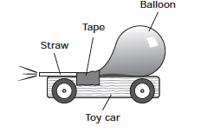
A | Test the car several times using an identical balloon filled with different amounts of air
B | Test the car several times using different-sized balloons filled with the same amount of air
C | Test the car several times using an identical balloon filled with the same amount of air
D | Test the car several times using different-sized balloons filled with different amounts of air
- Students are investigating how mass affects the force needed to move an object. They attached a wooden block to a spring scale and placed a 10 g mass on top of the block and pulled it 50 cm across a table top. As they did, they observed the force shown on the spring scale.
Which of the following describes the next step they should take in their investigation?
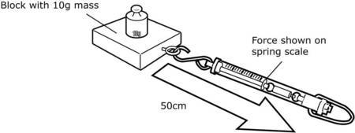
A | Pull the spring scale a longer distance.
B | Cover the table top with a carpet square.
C | Repeat the same steps using a heavier mass.
D | Attach a smaller block to the spring scale.
- Students wanted to see if the distance a marble rolled down a ramp changed the force it had. They allowed a marble to roll down the ramp from different starting points and strike a second marble.
To determine if the force of the rolling marble changed, what should the students measure?
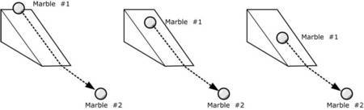
A | The mass of Marble #2 before and after being struck by Marble #1
B | The distance Marble #2 moves after being struck by Marble #1
C | The time it takes Marble #2 to move after being struck by Marble #1
D | The direction Marble #2 moves after being struck by Marble #1
- Students conducted an investigation in which they measured the distance a toy car traveled after rolling down a ramp covered with sandpaper or wax paper. Which of these questions can the students answer by analyzing the results of their investigation?
A | How does changing the height of a ramp affect the distance a toy car rolls?
B | How does changing the surface of a ramp affect the distance a toy car rolls?
C | How does mass affect the distance a toy car moves after rolling down a ramp?
D | How does the design of a toy car affect its movement after rolling down a ramp?
- Which two tools below would be most useful in testing how the mass of an object can affect the distance it moves after being pushed?
A | Spring scale and hot plate
B | Balance and meter stick
C | Graduated cylinder and beaker
D | Magnet and thermometer
- If a student has two magnets, how might it be determined which magnet is stronger?
A | Count how many paper clips each magnet can lift.
B | Submerge each magnet in a bowl of water.
C | Examine each magnet to determine the north pole.
D | Measure the length and mass of both magnets.
- Students conducted an investigation in which they rolled a soda can down a ramp that was 30 cm high and one that was 40 cm high. Which question were the students most likely trying to answer?
A | How does mass of a soda can affect the distance it will roll?
B | How does surface friction affect the distance a soda can will roll?
C | How does the size of a soda can affect the distance it rolls?
D | How does ramp height affect the distance a soda can rolls?
- A science class wanted to know if a golf ball and a table tennis ball would roll the same distance after rolling down a ramp. Which of the following shows a fair test of this idea?
A | 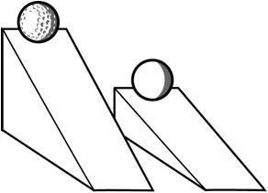
B | 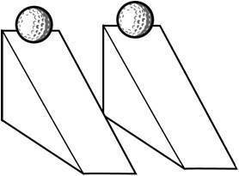
C | 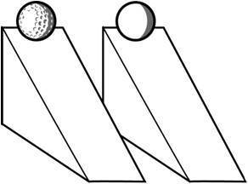
D | 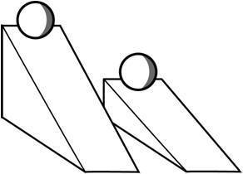
- A group of students wanted to compare the distances a toy car travels after leaving ramps of different heights. What tool would provide the most useful information for their comparison?
A | Stopwatch
B | Pan balance
C | Hand lens
D | Meter stick
- Students are investigating motion with a rubber band car. They want to know how the number of winds of the rubber band affects how the car moves. They will record the number of winds of the rubber band. What other data will they need to collect?
A | The distance the car travels when released
B | The length of the rubber band during each trial
C | The amount of time it takes to wind the propeller
D | The width of the surface on which the car moves
- A group of students collected the following data by pulling a toy car back different distances and then releasing it.
According to the data, the distance the toy car traveled increased as the -
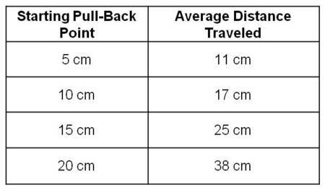
A | mass of the car was decreased
B | starting pull-back point increased
C | temperature in the classroom increased
D | surface on which the car rolled was changed
- Students create balloon rockets by taping drinking straws to balloons and running a thick string through the straw. The ends of the string are held tightly apart. When the balloon is inflated and released, it moves along the string.
What should the students do to change the amount of friction that slows the motion of the balloon rocket?
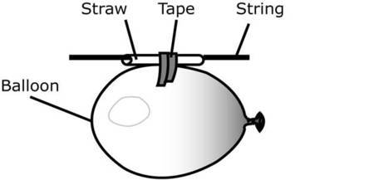
A | Try different color balloons.
B | Use a different type of tape.
C | Replace the string with thin wire.
D | Hold the string ends closer together.
- Students hung three washers on a string 20 cm long off the edge of a desk and timed how long it took the washers to swing back and forth one time.
They repeated the investigation, using the same three washers, with string that was 30cm and 40 cm long.
The students are testing the effect of which factor on the time it takes the washers to swing?
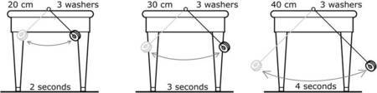
A | Height of desk
B | Length of string
C | Number of washers
D | Number of swings
- Some students wanted to find out if a tennis ball and a baseball dropped from the same height hit the ground at the same time. This investigation tests the effect of which of the following?
A | Wind
B | Friction
C | Gravity
D | Magnetism
- Students taped a rubber band to a box of washers, then dragged the box across four different surfaces, using the rubber band.
The students are using the distance the rubber band stretches to measure the amount of friction each surface exerts on the box. Based on the observations shown here, which surface had the greatest amount of friction?
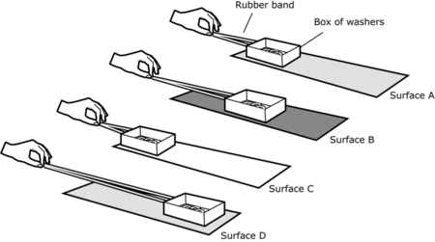
A | Surface A
B | Surface B
C | Surface C
D | Surface D
- Some students launched an air rocket several times. Each time they increased the number of pumps before releasing the rocket.
What data should they collect in order to test how the number of pumps affects the movement of the rocket?
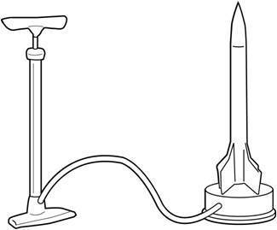
A | The height the rocket rises each time
B | The width of the rocket on its base
C | The distance from the pump to the rocket
D | The volume of air the pump holds
- A student designs an experiment to test the effect of the width of a piece of elastic on the elastic’s ability to stretch. The student selects four pieces of elastic with different widths but the same length. The student then attaches blocks with different masses to the pieces of elastic. The results of the student’s experiment are shown below. What should the student do to improve this experiment? (2015 STAAR, Q31)
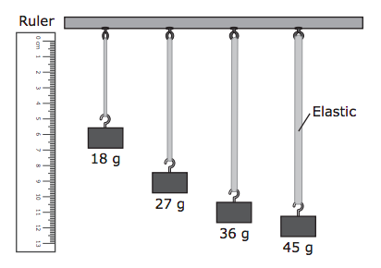
A | Use blocks of equal mass on the four pieces of elastic
B | Use blocks with enough mass to cause the four pieces of elastic to break
C | Use more than four pieces of elastic and four blocks
D | Use four pieces of elastic with different lengths but the same width
- A student observes that the craters on the moon are different sizes. The student designs an experiment to study the formation of craters. The materials for the experiment are marbles and a pan of flour. The student makes a hypothesis that the size of the craters made on the surface of the flour will depend on the height from which the marble is dropped. Some of the steps in the student’s experiment are described below. Which of these is most likely Step 3 in the student’s experiment? (2014 STAAR, Q10)
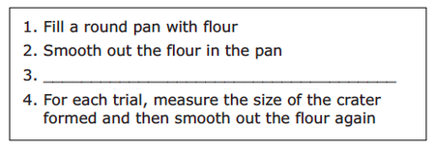
A | Drop the same marble from different heights into the pan of flour
B | Drop marbles of different masses from the same height into the pan of flour
C | Drop marbles of different sizes from different heights into the pan of flour
D | Drop a single marble one time into the pan of flour
- A student designs an experiment to test the force of a spring using a spring launcher and four spheres with the same diameter but with different masses. What other piece of equipment would be most useful for this experiment? (2014 STAAR, Q31)
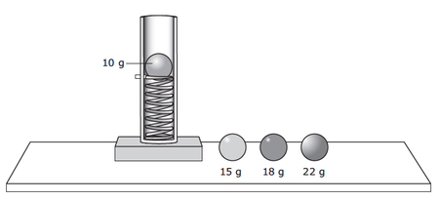
A | A graduated cylinder to measure the volume of each sphere before the sphere is launched
B | A beaker to collect the spheres after they are launched
C | A stopwatch to measure how long it takes to load each sphere on the spring
D | A meterstick to measure the height each sphere reaches after the sphere is launched

